Mountain Climber

Detailed Functional Specification
Version 2.0

S&M Productions
March 23, 2007

Table of Contents

Introduction ………………………………………………………… Page 2
General Description ………………………………………………… Page 2
Goals ………………………………………………………………... Page 2
User Interface ………………………………………………………. Page 3
Use Cases …………………………………………………………… Page 6
Data Storage ………………………………………………………… Page 7
Limitations ………………………………………………………….. Page 7

Introduction
This software application creates a visualization of census data. It uses a mountain climbing metaphor to show the income levels of different groups of people. It displays the amount of people in different race groups, professions and/or marital status in each income group. It helps users understand how a different life status can affect income.

General Description
The Java applet displays several “mountains” arranged side-by-side. A common goal in society is to increase one’s income. Therefore the idea of having a high income could be associated with climbing up a mountain and reaching the top. Therefore, in this application, mountains are built displaying low incomes at the base and high incomes at the peak.
There are three variable categories that the applet takes into account. Those three categories are marital status, race, and occupation. A user may select one of these categories, and the various values in the category will each be given their own mountain, displaying the income levels of people in that category value. For instance, if the user chooses to view the mountains by occupation, then each mountain will be a different occupation (skilled blue collar, farmer, etc.).
The data is presented by using a shaded region of each level of the mountain. The levels indicate income levels. For instance, one such level represents the $40,000 to $60,000 range. Each mountain level is then filled in with the percentage of people in the category value that fall in that range. The user can also choose to only concentrate on certain subgroups of other variable categories. For instance, if the mountains all represent different marital statuses, but the user only wants to concentrate on the Black population, then he need only check the “Black” checkbox under the “Race” category, and only the different levels of the Black population will be displayed.
Each level in the mountains will be colored differently and be viewed side-by-side or stacked, making it easier for the user to compare the data. This will also allow for easier comparisons as a whole, as it will be easy for the user to scan quickly across all the red levels and therefore compare the same income level across several mountains.

Goals
The main goal of this application is to display the census data in a clear way. The ability to manipulate the data in different ways is another key aspect. The application then acts as not only a standard visualization but also as a dynamic tool that can be altered to suit many different user needs. The central goal is to be completely dynamic and applicable to any user needs, while still maintaining the mountain metaphor and maintaining the ability to easily compare data side by side.

User Interface
The following image shows the basic features of the application.

Figure 1: General Overview

The Menu Options:
Build Mountains: This option opens a window which allows the user to have complete control over which demographics are displayed. It asks which characteristics each mountain should have. For example, a user could choose to display a mountain display the income levels of a white single woman and then have a second mountain which displays a Hispanic single male doctor. This option also allows the user to see side by side comparisons of the same group of people over specified years. Figures 2 and 3 display the box with which the user creates the mountains as well as a possible display.
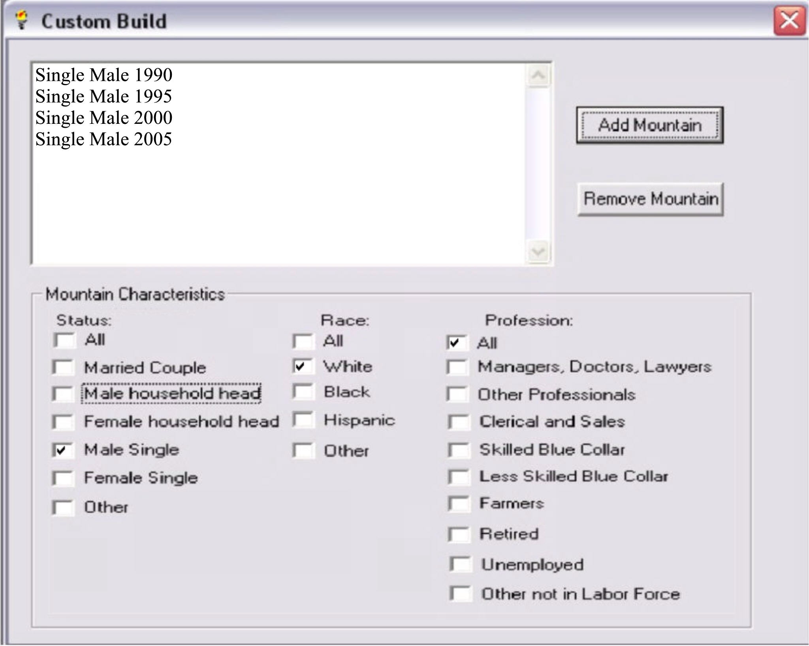
Figure 2: Custom Build Box
Figure 3: Custom Build Display

Edit Income Levels: This allows the user to choose the number or values of the levels on the mountain. If the user is not concerned with specific income levels, but rather just with the number of people for that specific group who are above the poverty level, then the mountain can be split into two levels, one above poverty and one below.
Professions: This is a list of the different professions covered in the data. The user can choose to display people in a specific profession, all professions, or draw the mountains using each profession as a single mountain.
Race: This menu provides the same uses as the professions menu except for each race.
Status: This menu provides the same uses as the professions menu except for each marital status.
View: This menu has many uses. It can determine whether the mountains are viewed at a side view (displayed in the image) or a stacked view (shows mountains one behind another, a little off center)(Figure 4). It can also choose whether to display mountains sized by scale (as seen in the image) or sized by the proportion of the mountain’s population to the total population. This second option means that if there is a larger group of unemployed women than there is of unemployed men, the mountain of unemployed men will be larger than the mountain of unemployed women. This size differentiation will be created by adjusting the area of the mountains but retaining the same heights so that the income levels continue to be the same across the display. The view menu also toggles labels to the mountains including the income levels, numerical values for each level, variables, as well as the poverty level. The user can mouse over the poverty and median lines and the exact numerical value will be displayed. The view menu also can determine whether the percentages relate to each mountain, income level, or to the entire population. Also, this menu determines whether the sizes of the income levels are drawn at equal heights or by equal area. Finally, the view menu allows the user to view the data in its text format.
Figure 4: Stacked View

Yearly: This menu allows the user to choose the begin year and end year, and to see an animation demonstrating how the income levels have changed from the beginning year to the ending year.
Help: This menu allows the user to see information about the application including developmental information as well as a guide on its use.
The Displayed Options:
In addition to the many menus at the top of the applet, there are several buttons below the graphic on the screen. These check boxes have the same functionality as the menu options, but with an easier interface for the user to handle quickly and effectively. The other options on the screen correspond to the functions already mentioned in the menu.
Display Information: This box describes the current information being shown and how it is broken up among the mountains.
The main graphic on the screen which shows the visualization currently shows four mountains. Each mountain represents a certain category group. Each black line in the mountain represents a different income level. The colors help to differentiate these levels. The amount of coloring each level has represents the percentage of people in that group who receive an income at that level. The poverty line and median income level line check boxes are checked, meaning that these levels are also displayed. The percentages are reported as integers above the shaded levels, as this check box is checked as well.

Use Cases
Students in John Grady’s sociology course need to do a research paper which requires information from the census data which happens to be included in this application. When formulating their ideas about what conclusions they can draw about black single women, they can easily see a visual depiction of this class using this application. They base their thesis around the idea the black single women make less money on average than white single women by choosing occupation as the variable, white as the race, and single as the marital status, and investigate the reasons behind this phenomenon.
The Census bureau is interested in seeing the increase of the average income of Hispanic single men since the 2000 census. They select Occupation as the variable, Hispanic as the race, and single man as the marital status, and view an animation that takes the data through the years specified by the bureau. By doing this, they are able to see the increase in the percentage of Hispanic single men with higher incomes.

Data Storage
The data is stored as census data. The data will describe several people, their occupation, their marital status, their annual income level, and their race. These values are then used to build the data base from where the target gets its information.

Limitations
The number of mountains could cause a visual issue if the user wishes to look at many mountains at once. If a user requests 5 mountains, or wants to show income varied by profession (which would require 9 mountains), the size of each mountain will get smaller which may make the data less clear.
Similarly, if the user chooses to display many different income ranges at once, the data could be squished vertically, making it more difficult to differentiate between the ranges.
One limitation is the lack of information a single set of mountains can display. Instead of being able to see several different variables at once, the user must choose a limited number of variables to display at any given time.

